Science 9
Household Electrical Energy

The Electric Meter

The electric meter was developed so that the amount of electrical energy being used by a house could be accurately measured and charged for by the company supplying the electrical energy. Electric meters measures electric energy use in watt·hours based on the equation:
$$∆E=P×∆t$$
How much energy is a kilowatt·hour?
$$1 kW∙h×\frac{1000W}{kW}×\frac{3600 s}{1 h}=3 600 000J$$

An average house in BC uses approximately 800 kW·h of electricity per month.
$$3 600 000J×800=2 880 000 000J or 2.88GJ$$

To simplify the reading of meters, the unit used today is the kilowatt·hour (kW·h) rather than such a large number of joules.

How to Read a Meter
The standard dial-type of meter is read from left to right, with the first dial representing the ten thousand place value.

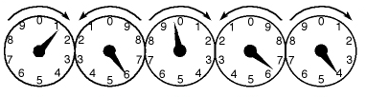
Example 1:

1 5 9 6 4

Example 2: 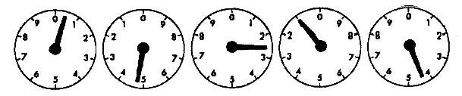

0 4 2 1 4

Electric meters are not reset each time they are read. Instead, the previous reading is subtracted from the current reading to determine how much electrical energy was used. By knowing how much electrical energy a household uses, a rate can be applied to calculate a cost for the use of the electrical energy.

Example 3: The reading of the electric meter from example 1 was read at 14 834 kW·h one month earlier. If the cost of electricity is $0.0667/ kW·h, what is the total amount billed?

$$15 964kW∙h-14 834kW∙h=1130kW∙h$$

$$1130kW∙h×\frac{\$0.0667}{kW∙h}=\$75.37$$

Example 4: Practice problem pg. 352
$$65 893kW∙h-65 372kW∙h=521kW∙h$$
$$521kW∙h×\frac{\$0.065}{kW∙h}=\$33.87$$

EnerGuide Labels
All household appliances sold today in Canada must have an EnerGuide label that outlines the appliance’s electrical energy usage and efficiency. The label provides the public with an estimate of how much electrical energy that appliance will use in a year based on a standardized level of use. This allows the consumer to make an educated decision on which appliance they will purchase.

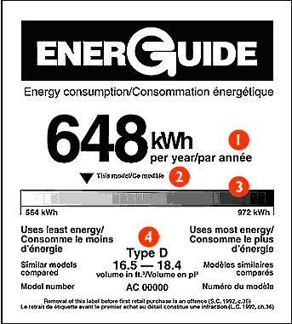
Example:
- The estimated amount of energy this appliance will use in a year.
- Arrow indicates how this model compares to other similar models. The further to the left the arrow is, the more efficient the appliance is and the cheaper it is to run.
- Bar shows the range of energy usage of comparable models – the most efficient model uses 564kW·h and the least efficient uses 972 kW·h of energy.
- Indicates the type and capacity range of comparable models.

When comparing different models, you need to make sure that you are comparing data from comparable appliances. For example, a larger fridge will normally have a higher energy usage than a smaller fridge because it a larger volume to keep cool.

Homework Check Your Understanding 11.4 (pg. 354) #1-8, 10-12
How to Read a Meter Worksheet
Electricity Use Problems Worksheet

